EXPLORE COPPER CANYON PLUS,
07 DAYS
Visiting: Chihuahua – Creel – Divisadero – Cerocahui – El Fuerte – Los Mochis
Departures: Departures Monday, Wednesday and Friday, from July to December 12, and Monday and Wednesday on june
Opera mínimo con 2 pasajeros
Duration: 7 days / 6 nights
Meals: according to itinerary

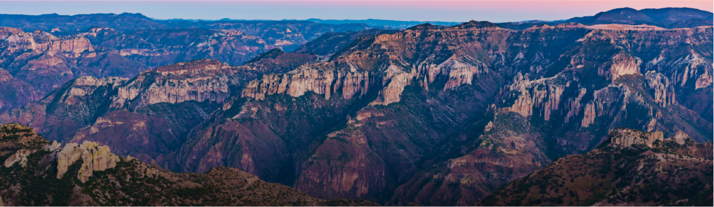

TRAVEL ITINERARY:
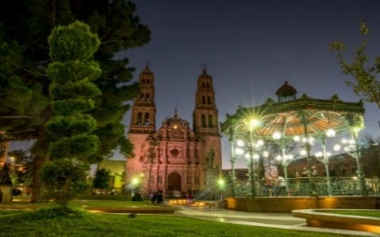

Day 1 Chihuahua
Airport transfer – hotel. Free day for an optional stroll through the city and its attractions: Pancho Villa Museum, Quinta Gameros, Miguel Hidalgo&#39;s Dungeon, and the historic downtown. Accommodation.

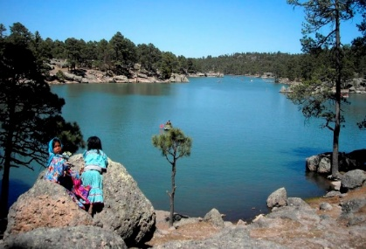
Day 2 Chihuahua – Creel
Breakfast. Transfer to Creel (Tourist category: by bus). Superior categories: breakfast included, departure by private car/van with panoramic Mennonite Tour, visiting this unique German-heritage community; optional entrance to the Cheese Museum. Optional lunch in Cuauhtémoc, then continue to Creel. Creel area tour included (Superior categories only): Lake Arareko, Valley of Mushrooms &amp; Frogs, Jesuit Mission. Return to Creel. Check-in. Free afternoon to stroll the village, visit the plaza, museum, and craft shops. Accommodation.

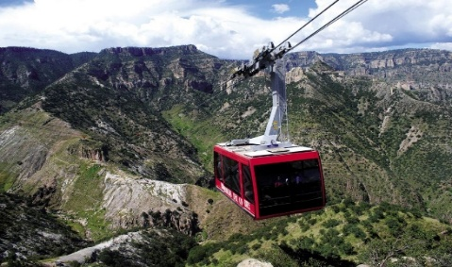
Day 3 Creel – Divisadero
Breakfast included. Ground transfer with luggage to Divisadero. Lookout Points Tour included:Adventure Park visit, optional cable car and zip line, Piedra Volada, hanging bridge. Optional: classic Divisadero gorditas. Check-in and rest. Guided hike or Tarahumara Cultural Experience in the canyon area and Tarahumara Cave. Dinner included (Superior categories). Accommodation..

Day 4 Divisadero – Cerocahui
Breakfast included. Free time to walk the canyon surroundings. Ground transfer to Cerocahui. Lunch included. Optional afternoon tour to Cerro del Gallego with views of the

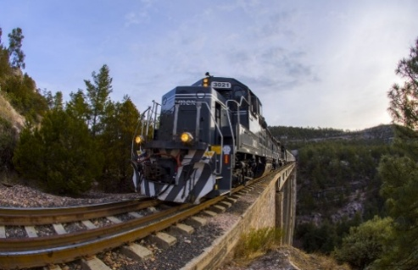
Day 5 Cerocahui – El Fuerte
Breakfast included. Free morning for an optional tour or walk through the village, its Jesuit Mission, and the Tarahumara girls boarding school. Transfer with luggage to the Chepe station to board the CHEPE EXPRESS train to El Fuerte, enjoying FABULOUS panoramic views of the
Sierra Tarahumara. Arrival in El Fuerte, transfer to hotel. Free afternoon to enjoy the plaza, museum, and the town’s attractions. Accommodation.

Day 6 El Fuerte
Breakfast included. Free morning. Walk through El Fuerte. Transfer to Los Mochis at the agreed time. Arrival at hotel in Los Mochis. Free afternoon: optional city stroll (Parque Sinaloa), optional tour to Topolobampo Bay, Maviri, and more. Accommodation and rest.

Day 7 El Fuerte
Transfer included at the agreed time to the airport or bus station. End of our services.

END OF OUR SERVICES.

PRICE PER PERSON IN US DOLLARS (USD):

TOURIST CATEGORY
Validity | Double | Triple | Quadruple | Single | Child  4 a 11
10/02/26-12/12/26 | USD 1,106 | USD 982 | USD 935 | USD 1,676 | USD 600

SUPERIOR EXECTUTIVE CATEGORY
Validity | Doble | Triple | Quadruple | Single | Child  4 a 11
10/02/26-12/12/26 | USD 1,412 | USD 1,206 | USD 1,165 | USD 2,012 | USD 700

SUPERIOR FIRST CLASS CATEGORY
Validity | Doble | Triple | Quadruple | Single | Child  4 a 11
10/02/26-12/12/26 | USD 1,735 | USD 1,529 | USD 1,412 | USD 2,412 | USD 876

Note: a maximum of 2 minors are allowed per room, sharing with 2 adults, breakfast and other meals for minors are not included.
***Rates do not apply on long weekends, holidays, vacation seasons,

THE PRICE INCLUDES TUORIST CATEGORY

- 1 night Hotel Plaza Chihuahua or HM Mirador or similar
- 1 night Hotel Taramuri, Sierra Bonita Creel, Santa Cruz Plus or similar
- 1 night Hotel Barrancas del Cobre or similar
- 1 night Hotel Paraíso del Oso in Cerocahui or similar
- 1 night Hotel Mansión Serrano El Fuerte or similar
- 1 night Los Mochis – Hotel Corintios, City Express or similar
- Tren chepe EXPRESS Bahuichivo – El Fuerte, TOURIST CLASS (approx. 5 hrs)
- Airport transfer CUU – Hotel CUU
- Bus transfer Chihuahua – Creel
- Van/car transfer Creel – Divisadero (from 2 passengers)
- Van/car transfer Divisadero – Cerocahui
- Transfer El Fuerte Station – Hotel
- Transfer Hotel El Fuerte – Hotel Los Mochis
- Transfer Hotel Los Mochis – Airport
- 1 breakfast in Creel
- 1 breakfast in Divisadero
- 1 lunch in Cerocahui
- 1 dinner in Cerocahui
- 1 breakfast in Cerocahui
- 1 breakfast in El Fuerte
- Lookout Points Tour – Adventure Park visit (cable car & zip line NOT included)
- Guided hike – Tarahumara Experience at Barrancas del Cobre and Tarahumara Caves
- Transfers within the Sierra Tarahumara

THE PRICE INCLUDES SUPERIOR EXECUTIVE CATEGORY

- 1 night Hotel HAMPTON INN or similar
- 1 night Hotel VILLA MEXICANA or HACIENDA TARAMURI or similar
- 1 night Hotel DIVISADERO or similar
- 1 night Hotel PARAÍSO DEL OSO in Cerocahui or similar
- 1 night Hotel LA CHOZA or MANSIÓN SERRANO El Fuerte or similar
- 1 night Los Mochis – Hotel SANTA ANITA, PLAZA INN or similar
- *Chepe EXPRESS Train Bahuichivo – El Fuerte, EXECUTIVE CLASS (recorrido de aprox. 5 horas)
- Airport transfer CUU – Hotel CUU
- Van/car transfer Chihuahua – Creel (from 2 passengers)
- Van/car transfer Creel – Divisadero
- Van/car transfer Divisadero – Cerocahui
- Transfer El Fuerte Station – Hotel
- Transfer Hotel El Fuerte – Hotel Los Mochis
- Transfer Hotel Los Mochis – Airport
- 1 breakfast in Chihuahua
- 1 breakfast in Creel
- 1 dinner in Divisadero (beverages not included)
- 1 breakfast in Divisadero
- 1 lunch in Cerocahui
- 1 dinner in Cerocahui
- 1 breakfast in Cerocahui
- 1 breakfast in El Fuerte
- MENNONITE FIELDS TOUR (panoramic; optional cheese museum entrance from 2 passengers)
- CREEL & SURROUNDINGS TOUR: Lake Arareko, Valley of Mushrooms & Frogs,
- Jesuit Mission, San Sebastián Cave (from 2 passengers)
- Lookout Points Tour – Adventure Park visit (cable car & zip line NOT included)
- Guided hike at Barrancas del Cobre and Tarahumara Cave
- Transfers within the Sierra Tarahumara

THE PRICE INCLUDES SUPERIOR FIRST CLASS CATEGORY

- 1 night Hotel QUALITY INN, FIESTA INN, SHERATON or similar – Chihuahua
- 1 night Hotel THE LODGE AT CREEL, QUINTA MISIÓN, HACIENDA DON ARMANDO or similar
- 1 night Hotel MIRADOR or similar
- 1 night Hotel MISIÓN CEROCAHUI or similar
- 1 night Hotel POSADA DEL HIDALGO or similar – El Fuerte
- 1 night Los Mochis – BEST WESTERN PLUS, FIESTA INN or similar
- Chepe EXPRESS Train Bahuichivo – El Fuerte, FIRST CLASS (recorrido de aprox. 5 horas)
- ACCESS TO CRYSTAL TERRACE car and second-floor DOME car on CHEPE
- Airport transfer CUU – Hotel CUU
- Van/car transfer Chihuahua – Creel (from 2 passengers)
- Van/car transfer Creel – Divisadero
- Van/car transfer Divisadero – Cerocahui
- Transfer El Fuerte Station – Hotel
- Transfer Hotel El Fuerte – Hotel Los Mochis
- Transfer Hotel Los Mochis – Airport
- 1 breakfast in Chihuahua
- 1 breakfast in Creel
- 1 dinner at Posada Barrancas (beverages not included)
- 1 breakfast at Posada Barrancas
- 1 lunch in Cerocahui (no incluye bebidas)
- 1 dinner in Cerocahui (no incluye bebidas)
- 1 breakfast in Cerocahui
- 1 breakfast in El Fuerte
- MENNONITE FIELDS TOUR (panoramic; cheese museum entrance NOT included)
- CREEL & SURROUNDINGS TOUR: Lake Arareko, Valley of Mushrooms & Frogs,
- Jesuit Mission and San Sebastián Cave
- Lookout Points Tour – Adventure Park visit (cable car & zip line NOT included)
- Guided hike at Barrancas del Cobre and Tarahumara Cave
- Transfers within the Sierra Tarahumara

THE PRICE DOES NOT INCLUDE

- Plane ticket City of Origin – Chihuahua / Los Mochis – City of Origin
- Optional tours
- unspecified meals,
- optional transfers
- Anything not listed
- Lodging Insurance
- Flights
- ADVENTURE PARK ENTRANCE and COMMUNAL / HISTORIC SITE ENTRANCE FEES
- Tips to porters, waiters, guides and operators. Voluntary tips for your consideration.

IMPORTANT:

- Prices per person expressed in US Dollars, subject to change without prior notice and availability at the time of booking.
- Rates NOT valid during September 17 to 25, Holidays, Christmas, New Year and special conference dates for those dates, please consult.
- The order of the planned services mentioned in this itinerary could be modified depending on land availability or climatic conditions of the place, but they will always be given as they were acquired.

- The check-in and check-out times of the hotels are subject to the formalities of each hotel, and may have the following times: Check In 15:00 Hrs. and Check Out 12:00 Hrs. (Tomorrow). If arrival is before the established time, there is a possibility that the room will not be provided until the corresponding time. If your plane returns in the afternoon, the hotel will be able to keep your belongings.
- The transfer and excursion services in this quote are provided as regular services, these services are subject to pre-established schedules and are provided together with other passengers. Check prices for private service.
- The Rate for children is applicable between 3 and 11 years old accompanied by two adults.
- Unused services are NON-REFUNDABLE.
- is not responsible for objects left in the units, since it is primarily the responsibility of the clients to take care of their belongings, as well as for luggage that does not arrive on the flight; They will be given support to recover it, but there is no obligation to remunerate the passenger.
- For passengers with a disability, it is important that they travel with a companion who can help them on the journey (get on, get off or walk). You are asked to indicate this situation when booking to take precautions.
- Package operable with a minimum of 2 people.
- Consult supplement for transfers to and/or from the airport at night.

PRIVACY NOTICE:

In compliance with the provisions of article 15 of the Federal Law on Protection of Personal Data Held by Private Parties (LFPDPPP), we inform you that your personal data that you provide freely and voluntarily through this or any other means will be subject to the provisions of the Entorno CIT Privacy Notice which can be consulted on the website: www.entonocit.com

VALID FROM JUNE 10 TO DECEMBER 12, 2026.
PREPAYMENT IS REQUIRED

CANCELLATION POLICIES
- Between 50 and 34 days a 50% charge per person will be charged.
- Between 33 and 25 days, charges of 80% will be charged.
- Within 24 days before departure, the charges will be 100% of the total amount of the trip.
- You can transfer a trip or make a name change up to 8 days before (charges apply)

This document is of an informative nature, but not a confirmation.

